_________________________________________________________________________________________________________________________________________________________________________________________________________________________________________________________________________________________________________________________________________________________________________________________________________________________________________________________________________________________

What led to the rise and success of piracy in the Caribbean Sea during the 18th century?

_________________________________________________________________________________________________________________________________________________________________________________________________________________________________________________________________________________________________________________________________________________________________________________________________________________________________________________________________________________________

Overview: During the 18th century there was a sharp rise in pirate activity in the Caribbean Sea. This era was known as the Golden Age of Piracy. During this time pirates such as Henry Morgan, Blackbeard, and William Kidd became famous. This assignment will ask you to figure out what factors led to the rise and success of piracy in the Caribbean Sea during the 18th century.

The Documents:
Document A: Letter of Marque (text)
Document B: Inventory of treasure cache of William Kidd (text)
Document C: Bermuda Sloop and Spanish Galleon (photos)
Document D: Captain Robert’s Crew (picture)
Document E: Journal of Jean Lafitte (text)
Document F: Painting 30 Years War (painting)
Document G: Caribbean Sea (map)

Document A

Source: Edwards, L., Benson, S., Stock, J. (2011). Pirates Through the Ages: Primary Sources. Farmingtin Hills, MI: Gale Cengage Learning

“Many of history’s major pirate eras began with governmental policies that encouraged the licensing, through Letters of Marque, of privateers, private ships or ship owners commissioned by their government to raid enemy ships during wartime. The actual work that pirates and privateers do is the same. They attack ships, usually merchant vessels, or coastal communities, and they use violence or the threat of violence to rob their victims of valuables, sometimes taking the ship itself as a prize. The main difference between pirates and privateers is that pirates work solely for their own profit, while privateers, at least in theory, work for their country. While piracy is illegal, privateering is considered legal, at least by the nation that licenses the privateers.”

Source: Kennedy, N. (n.d.). Letter of Marque. Retrieved from http://www.lomtheater.org/whats-a-letter-of-marque.html

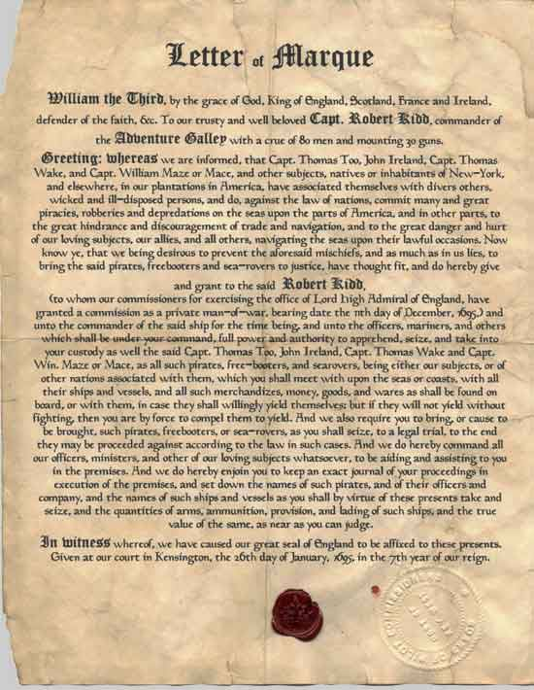

Document Analysis
- What is a Letter of Marque?
- What was the difference between a Pirate and a Privateer?
- Why would a government want or need to issue a Letter of Marque?
- How would the issuing of Letters of Marque affect the practice of piracy during the 18th century?

Document B

Source: Paine, R. (2000). The Book of Buried Treasure. Retrieved from http://www.gutenberg.org/files/33318/33318-h/33318-h.htm#img-082
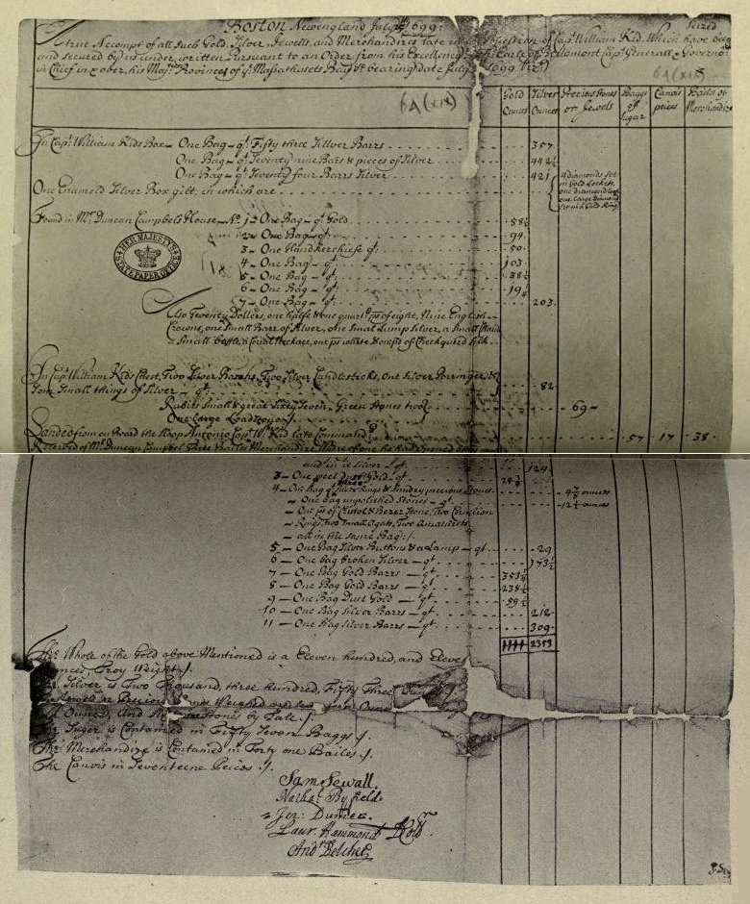

Some pirates kept numerous treasure caches throughout their careers. The inventory above lists some of the valuables found in one of Captain William Kidd’s many caches.

Based on the figures of the inventory, the cache included:
- Gold: Eleven hundred, and Eleven ounces or 70 lbs. (approx $1.4 million)
- Silver: Two Thousand, three Hundred, Fifty-three ounces or 150 lbs. (approx $47,500)
- Numerous precious stones to include 6 diamonds (approx $500,000)

Document Analysis
- How much is the approximate value of the treasure found in the cache?
- How would this encourage people to become pirates?
- For what reasons do you think pirates would keep treasure caches?

Document C

Source: The Mariner’s Museum. (n.d.). Pirates: Bermuda Sloop Retrieved from http://www.marinersmuseum.org/stamp-history/pirates-bermuda-sloop | Source: Kirsch, P. (1990) The Galleon: the great ships of the Armada era. London, EN : Conway Maritime
Bermuda Sloop  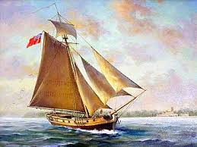 | Galleon  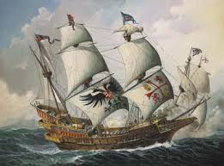
“Although some pirates felt that large ships enhanced their threatening persona, most preferred the maneuverability of smaller vessels. The ideal pirate ship was the Bermuda sloop. Derived from a Caribbean cargo ship, the sloop was fast enough to outrun most warships and small enough to hide in shallow rivers and coves where a larger vessel could not follow.” | “The main war ship and transport ship used during the 16th and 18th centuries, the Galleon, was large enough to serve both functions. Its large size enabled it to carry large amounts of cannon, personnel, and equipment. It was especially durable during combat and stormy weather which were both frequently encountered in the Atlantic and Caribbean.”

Document Analysis
- What are some distinguishing features of a Bermuda sloop?
- What are some distinguishing features of a Galleon?
- How could either ship benefit pirates, merchants, and naval forces?
- How could the use of specialized ships increase the success of pirates in the Caribbean?

Document D

Source: Paine, R. (2000). The Book of Buried Treasure. Retrieved from http://www.gutenberg.org/files/33318/33318-h/33318-h.htm#img-082

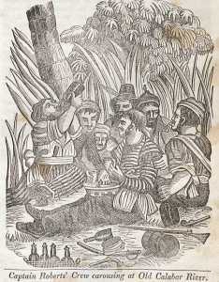

Pirating offered out of work sailors a way to make a living. Most were not knowledgeable in other available jobs such as farming. Although considered dangerous work, pirates tended to live a life in which they were allowed to enjoy themselves. When in port, pirates would spend much of their booty on alcohol, gambling, tobacco and other areas of enjoyment.

Document Analysis
- What can you see the pirates doing in the picture? Are they enjoying themselves?
- How would the lack of work and unemployed workers affect piracy?
- How would this lifestyle affect the levels of piracy?
- What other jobs could sailors get in the new world?

Document D

Source: Lafitte, J. (1994). The Journal of Jean Lafitte. Brandon, MS: Dogwood Press

Jean Lafitte was a French pirate which operated in the Gulf of Mexico. This is an excerpt from his journal in which he describes his older brother’s, Alexandre, return from a pirate raid.

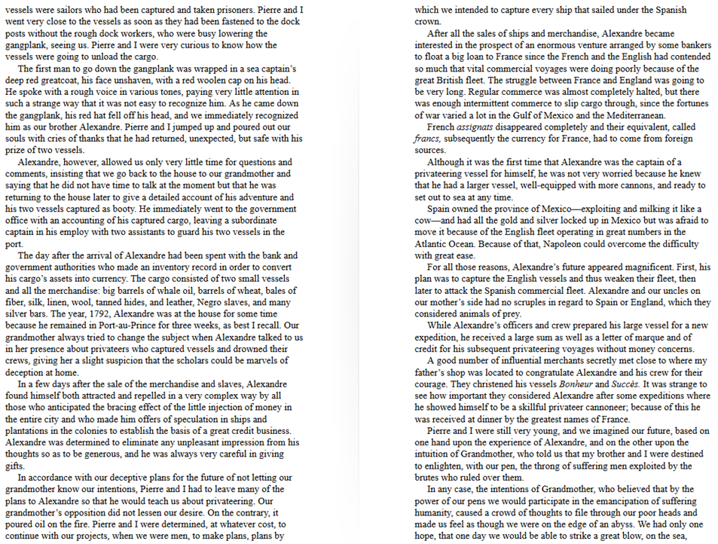

Document Analysis
- How did the people treat Alexandre after his return?
- What was he able to bring back from the raid?
- How would the respect and wealth offered to successful pirates affect the overall level of piracy in the Caribbean?

Document E

Source: Wahlborn, C. (1855). Death of King Gustav II Adolf at the Battle of Lutzen

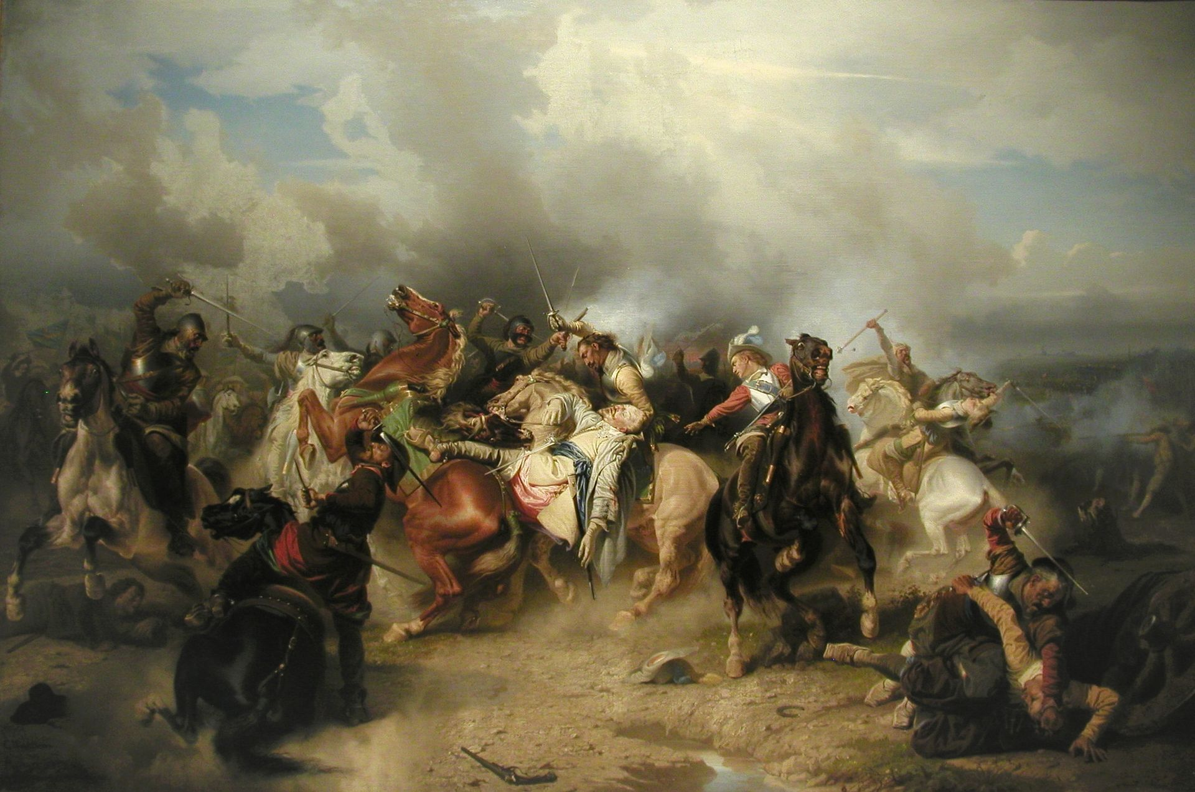

Source: Wilson, P. (2011). The Thirty Years War: Europe’s Tragedy. Cambridge, MS: Harvard University Press

The Thirty Years' War (1618–1648) was a series of wars principally fought in Central Europe, involving most of the countries of Europe. It was one of the most destructive conflicts in European history, and one of the longest continuous wars in modern history. Although the war ended 50 years prior to the 18th century, the large scale of the war and its effects did not allow the European powers to place a significant amount of resources into the West Indies until much later.

Document Analysis
- Who was involved in the Thirty Years War?
- Of these powers, which of them had interests in the Caribbean?
- How would the amount of resources that these nations placed in the war affect what they could do in the Caribbean?
- How would this affect piracy?

Document F

Source: Map created from various sources

Document Analysis
- What characteristics do the pirate ports have in common?
- Why were they located where they were?
- How would the locations of the pirate ports in relation to the Spanish trade route affect the level of success pirates had?
- What other benefits can you see in having pirate ports?

Bucketing- Getting Ready to Write

Bucketing

Look over all the documents and organize them into your final buckets. Write final bucket labels under each bucket and place the letter of the documents in the buckets where they belong. It is okay to put a document in more than one bucket. Remember, your buckets are going to become your paragraphs.

Thesis Development and Road Map

Use the chickenfoot below to write your thesis and roadmap. Your thesis is always an opinion and answers your document based question. The roadmap is created from your bucket labels and lists the topic areas you will examine in order to prove your thesis.

From Thesis to Essay Writing

Mini DBQ Essay Outline Guide

Working Title
Paragraph #1
Grabber
Background
Stating the question with any key terms defined and described
Thesis and roadmap
Paragraph #2
Baby Thesis for bucket one
Evidence: supporting detail from documents with document citation
Argument: connecting evidence to the thesis
Paragraph #3
Baby Thesis for bucket two
Evidence
Argument
Paragraph #4
Baby Thesis for bucket three
Evidence
Argument
Paragraph #5
Conclusion: Restatment of the main idea along with possible insight or wrinkle

